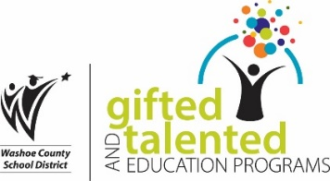Family Information night

# The GATE Institute Fall 2021

is the GATE institute the best option for my gifted child?

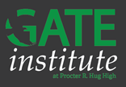While many choices are available, The GATE Institute offers a unique opportunity specifically designed for gifted and talented students. The innovative Institute offers accelerated pathways, GT specific courses, AP Capstone diploma offered by the College Board, streamlined dual-enrollment process, Health Science Signature Academy & medical pathways, early access to Advanced Placement courses, and more– all inside a comprehensive high school campus, with as many clubs and extra-curricular activities a student could want!

Join Us!

Meet representatives from The GATE Institute to walk you through all you need to know!

|  |
| --- |
| **November 15th at 6pm** |
| Join Zoom Meeting  <https://us06web.zoom.us/j/5040015580?pwd=MURTbWV4MWJVM3VybEFUN1hYSGQvdz09>  Meeting ID: 504 001 5580  Passcode: GATE |
| **November 17th at 6pm** |
| Join Zoom Meeting  <https://us06web.zoom.us/j/5040015580?pwd=MURTbWV4MWJVM3VybEFUN1hYSGQvdz09>  Meeting ID: 504 001 5580  Passcode: GATE |

**The New School @ Wildcreek**

[**https://www.youtube.com/watch?v=hl7L6O5lFi8&feature=youtu.be**](https://www.youtube.com/watch?v=hl7L6O5lFi8&feature=youtu.be)

**https://www.washoeschools.net/Page/14240**

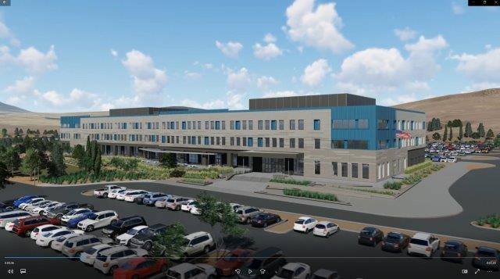



# the department of gate program: 775-789-3420 [giftedandtalented@washoeschools.net](mailto:giftedandtalented@washoeschools.net)